MOP

By Don Chen

# Description

We are onboarding 2 new access switches to our network.

# Prerequisites

* Access and logins to ISE.

# Step-by-Step Instructions

1. Open the CLI of Access_SW_02.
2. Use the switch configuration template file included with the MOP, but make sure to replace the “<IP of Switch>” with the appropriate IP. In this case, use “172.16.101.3”.
3. Copy and paste that into the switch
4. Go to the ISE GUI by typing 172.16.100.50 while in the browser.
5. Log in.
6. Go to Administration -> Network Devices. Then click Add.

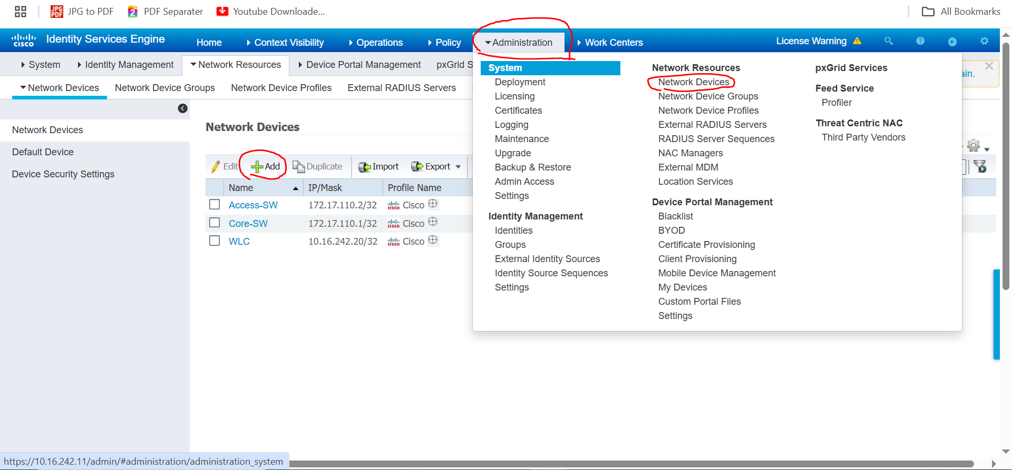

1. Input the information to match the screenshots below. For the next switch, remember that the name and the IP address will be different. Click “Submit” after you matched the screenshots.

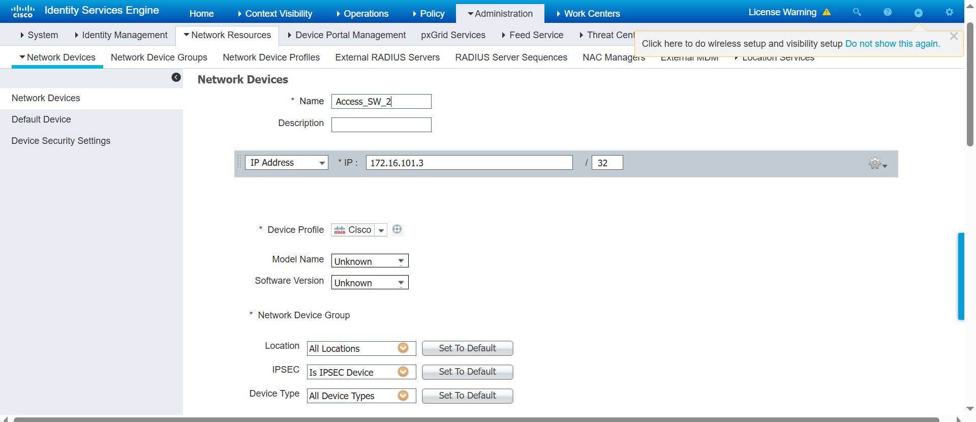

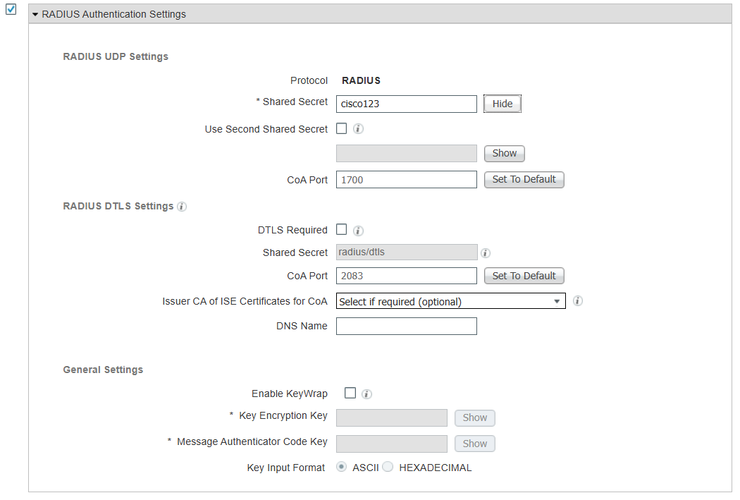

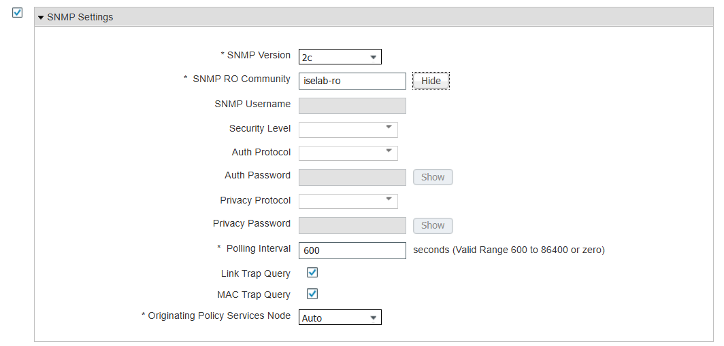

1. Now repeat for the second switch. Remember, the second switch has a different IP address, so take extra care in steps 2 and 7.

# Verification

1. Access privileged exec mode of the access switches.
2. Use the command “show aaa servers”. You should see a screenshot similar to one the below.

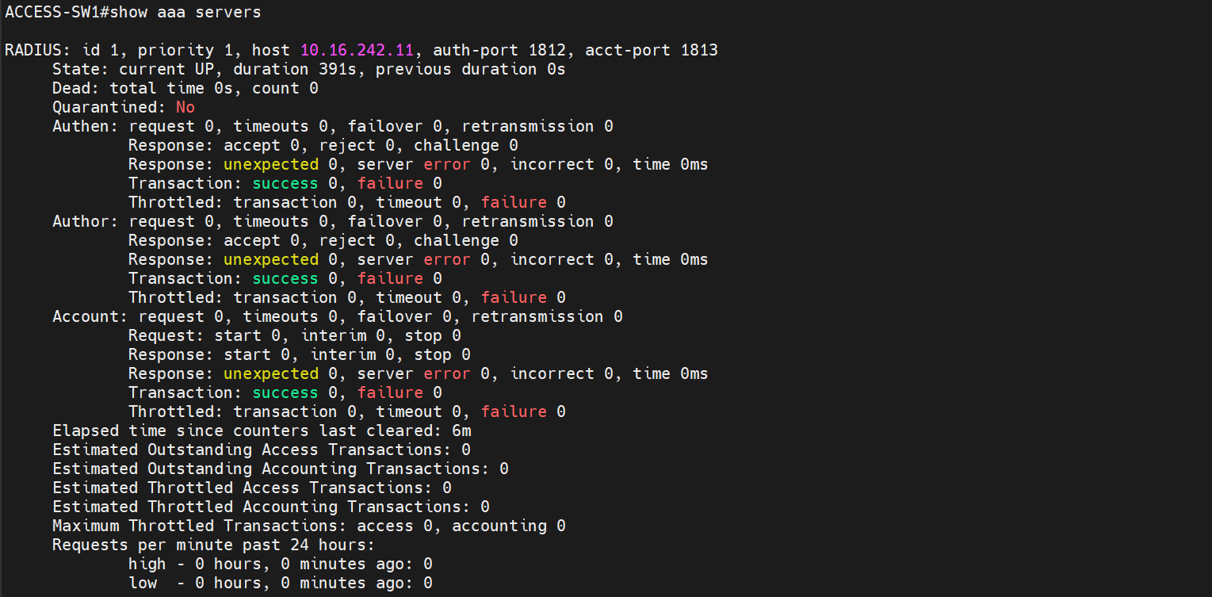

1. Access the ISE GUI and log in.
2. Navigate to Operations -> Radius -> Live Logs. You should see something similar to the screenshot below. Make sure you find the IP address of the two switches we added.

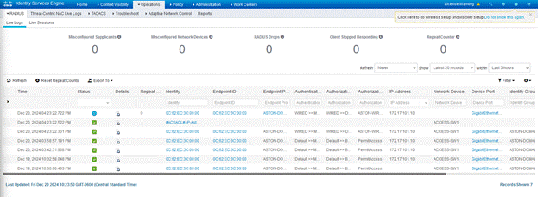

# Rollback Plan

1. Factory reset the switches by logging into privileged exec mode, then using “write erase”.
2. Access the ISE GUI and Log in.
3. Go to Administration -> Network Devices.
4. Checkmark the two new switches, then click “Delete”, select “Delete Selected”. This step will look similar to the screenshot below.

